**TEAM4OIES**

**TEAM4OIES Database Implementation Screenshots**

***Version 2.0***

**Approvals Signature Block**

|  |  |  |  |
| --- | --- | --- | --- |
| **COSC 3380** | **Name** | **Signature** | **Date** |
| DB SQA |  |  |  |
| DB SQA |  |  |  |
| SE Team Leader |  |  |  |
| SE SQA |  |  |  |
| SE SQA |  |  |  |

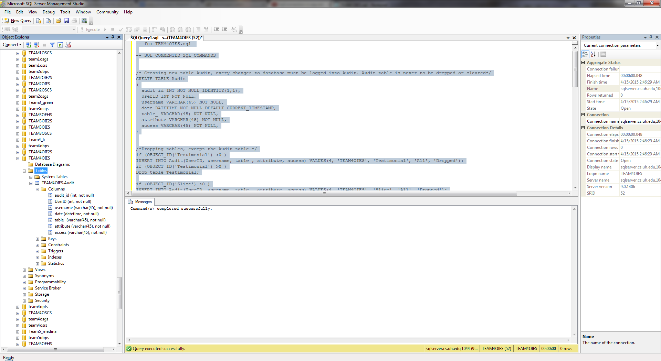

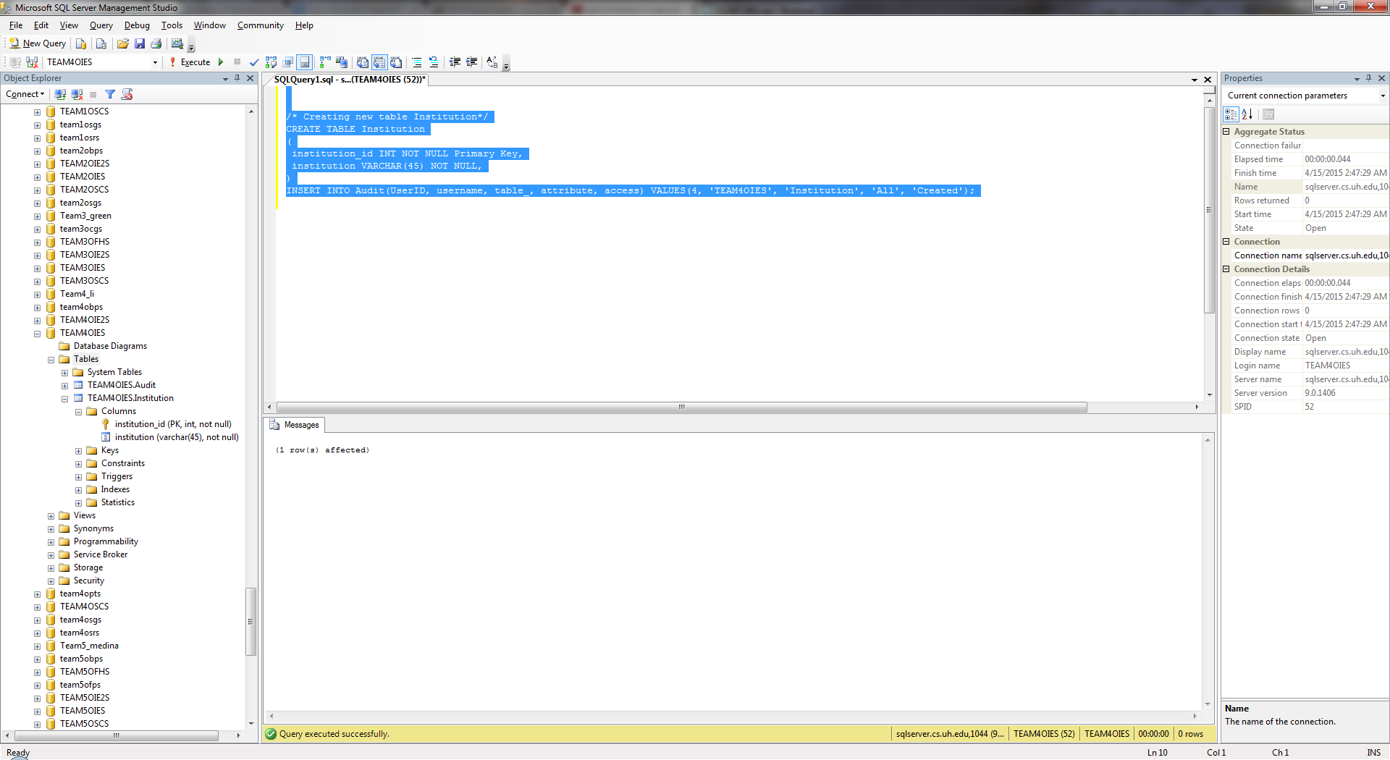

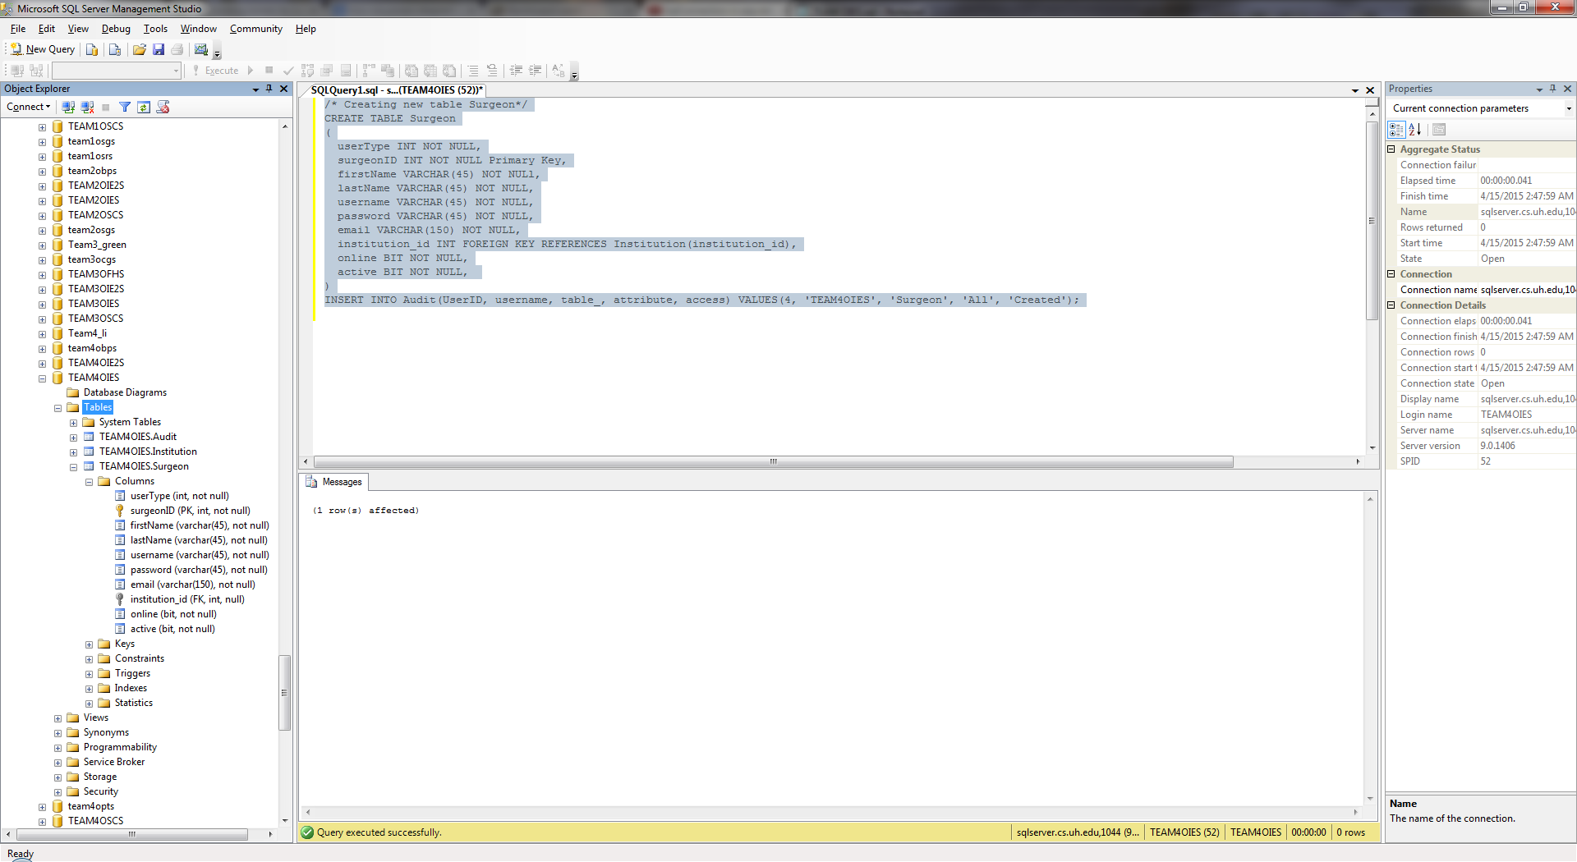

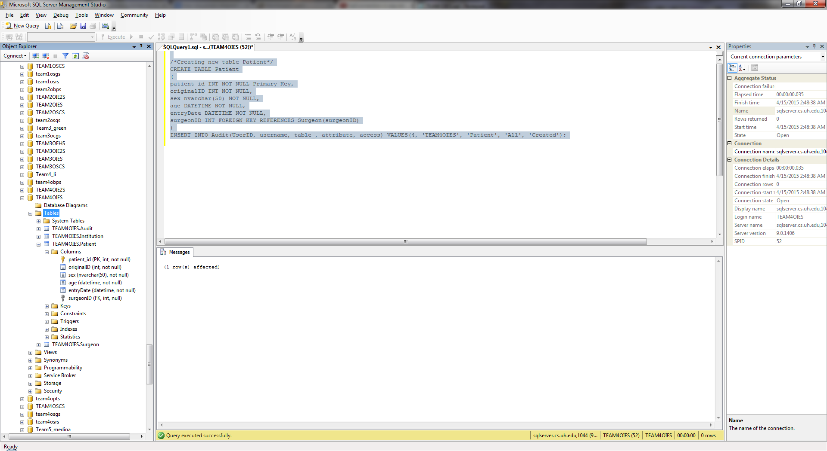

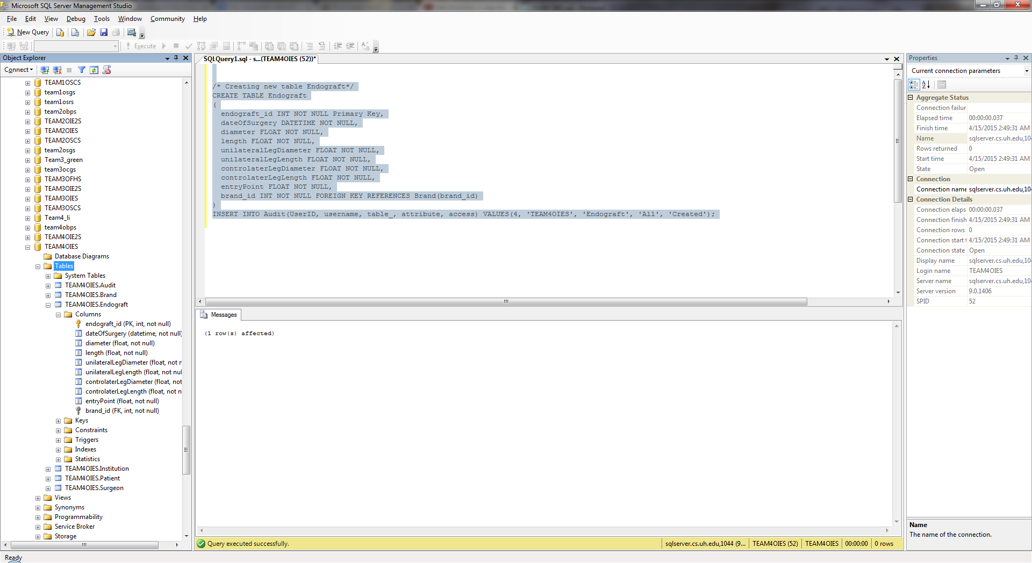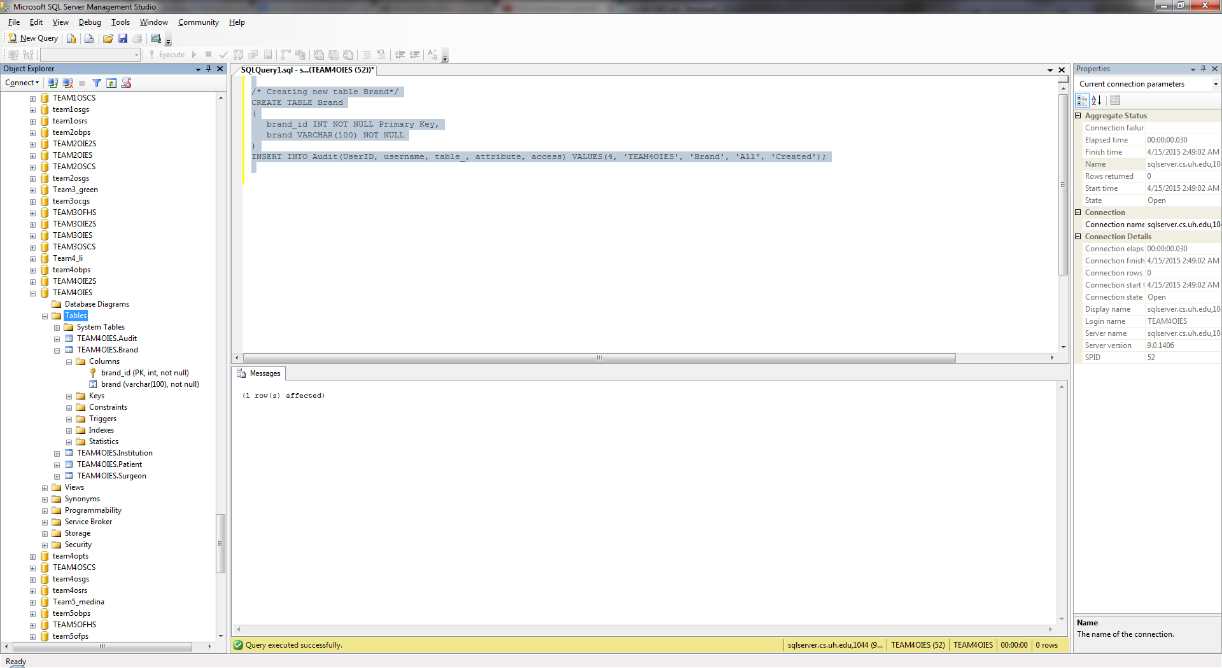

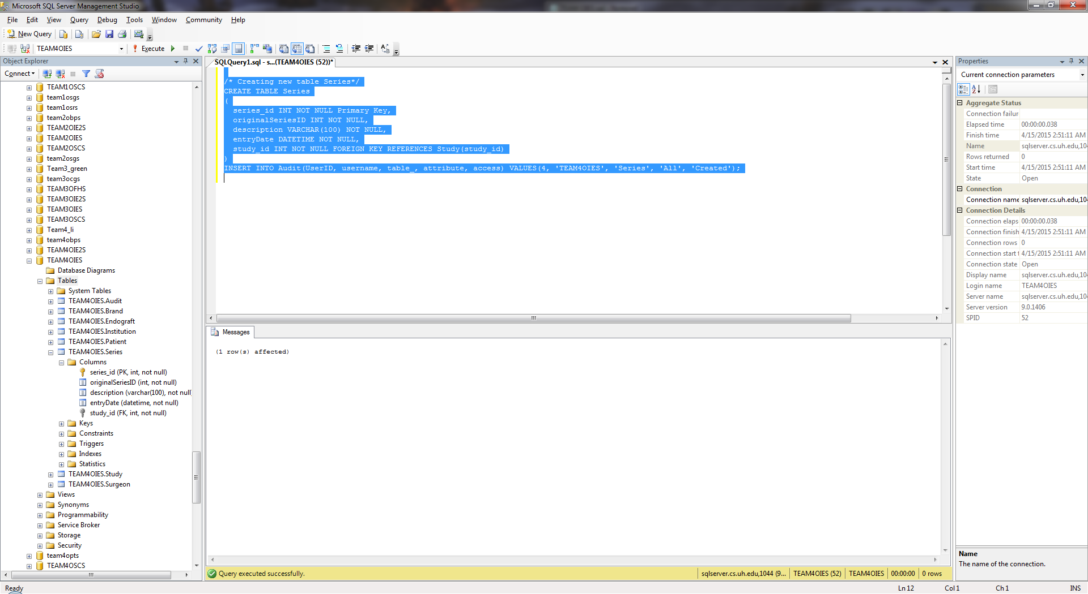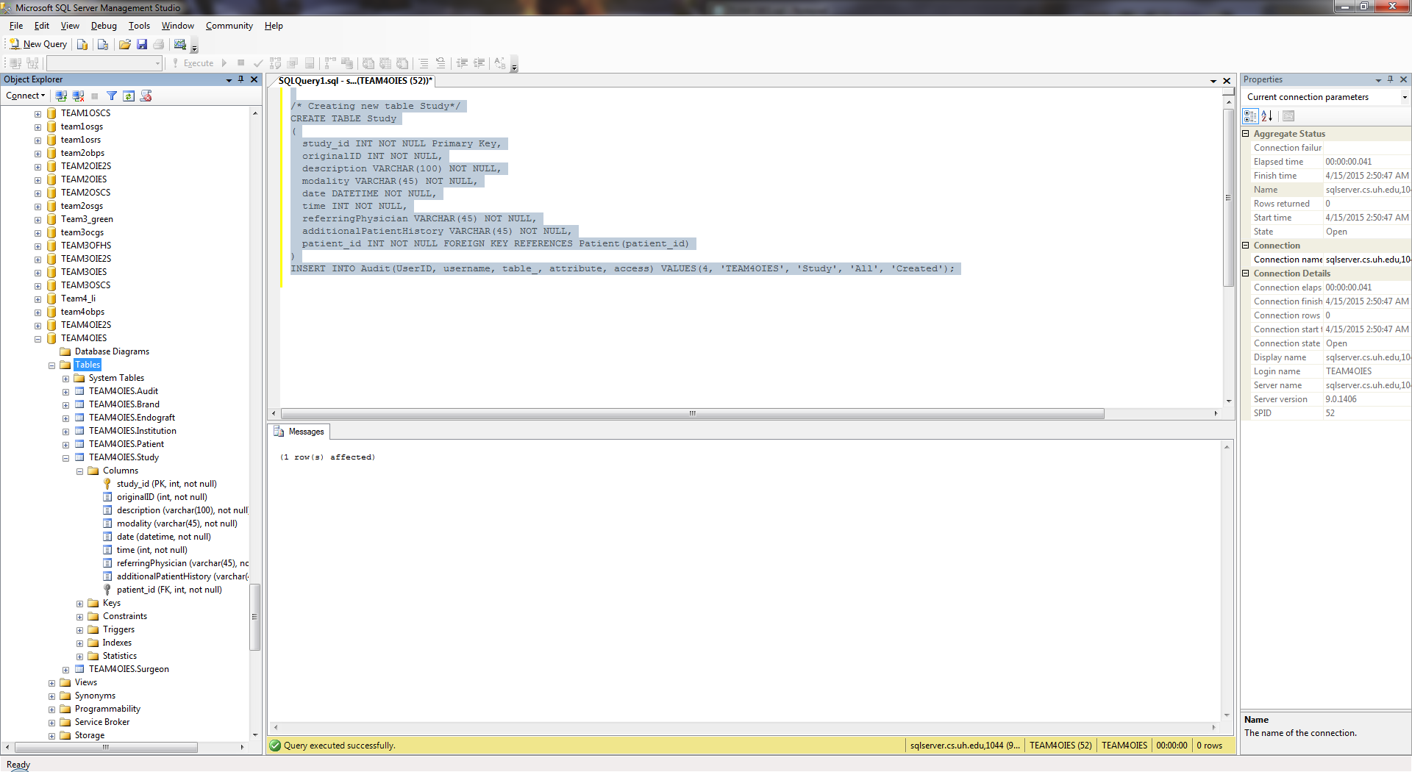

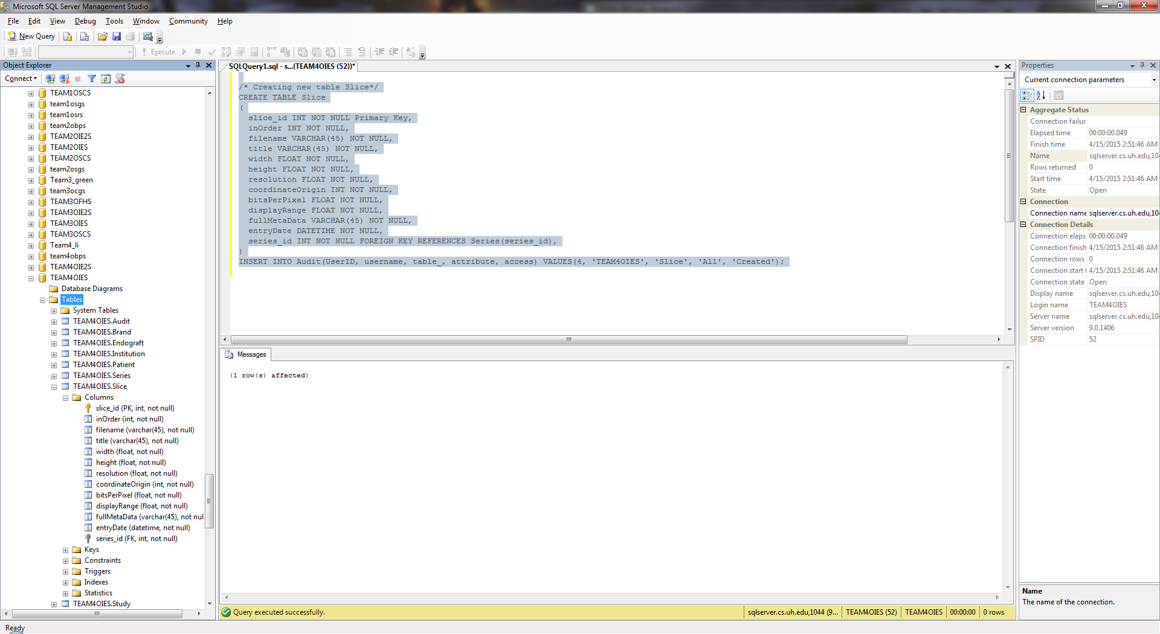

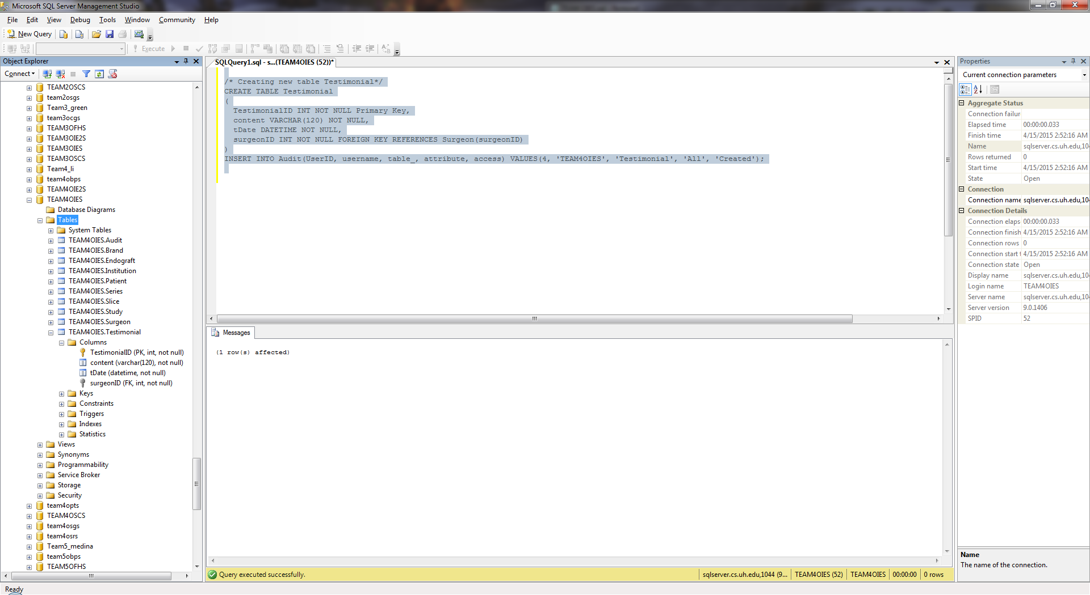

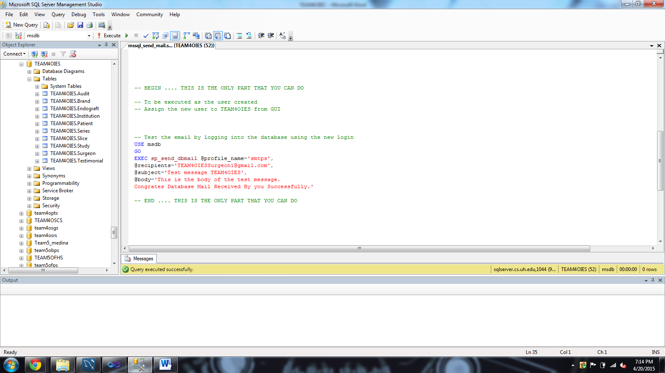

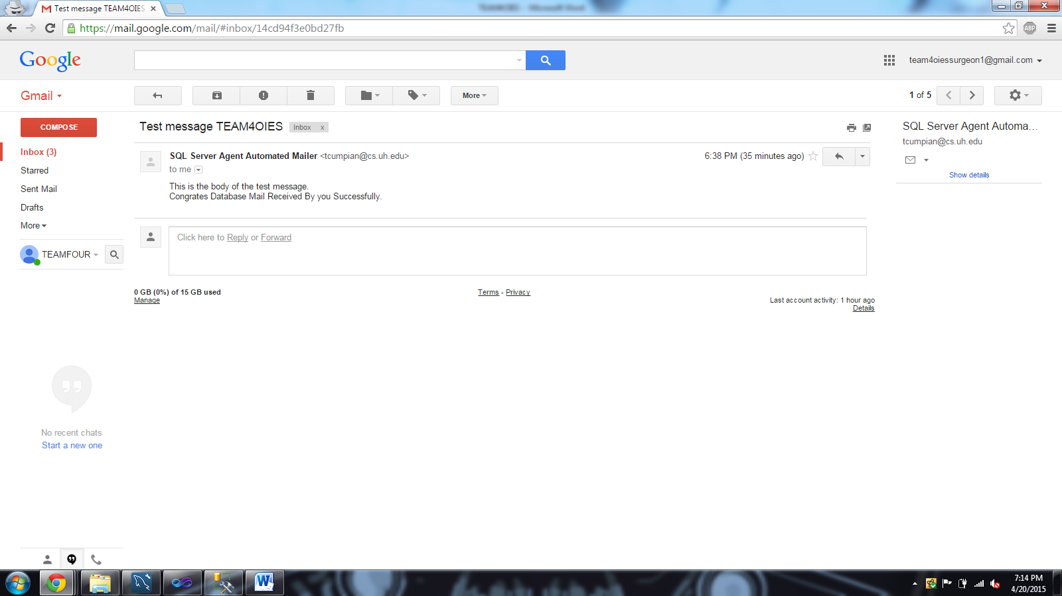

**Document Control**

Change History

**Table 1: TLs entries (assigned work and due dates) before releasing to the team (all SQAs)**

|  |  |  |  |
| --- | --- | --- | --- |
| Revision | Name | Due Date | Description |
| 1.A | DBA Logan Stark | 04/12/2015 | Complete Read ,Implement |
| 1.B | DBA Jainesh Mehta | 04/12/2015 | Complete Verify And Submit |
|  |  |  |  |
| 1.X | SQA Linh Tong | 04/14/2015 | Review Document |
| 1.Y | SQA Paul Miller | 04/14/2015 | Review Document |

**Table 2: Entries when work completed (SVN Commit Comment matches Description)**

|  |  |  |  |
| --- | --- | --- | --- |
| Revision | Name | **Completed Date** | Description |
| 1.A | DBA Logan Stark | 4/15/2015 | Complete Read ,Implement |
| 1.B | DBA Jainesh Mehta | 04/14/2015  04/15/2015 | Added screenshots  Fixed screenshots of updated tables. |
| 1.C | DBA Logan Stark | 4/20/2015 | Sent email using SQL code  Added corresponding screen shots |
|  |  |  |  |
| 1.X | SQA Linh Tong | 04/14/2015 | Review Document |
| 1.Y | SQA Paul Miller | 04/14/2015 | Review Document |

**Table 3: TL entry for BLUE DELIVERABLES (SVN Commit Comment matches Description)**

|  |  |  |  |
| --- | --- | --- | --- |
| Revision | Name | Due Date | Description |
| 2.0 | TL Javier Rivera | 04/15/2015 | I changed Version to 2.0 |

Document Storage

This file is stored in SVN at https://svn.cs.uh.edu/svn/cs4351/team**4**/DB TEAM PROJECT DELIVERABLES/ **TEAM4OIES.doc**.